**Register test case**

**Goal:**

As a tester, I want to verify if the Register form is correctly and if the formulary is filled with: e-mail, password, confirm password, name, last name, phone number, street, house number, city and postal code.

**Background:**

Register page is responsible to register and verify the specifications from the user and create a new account.

**Steps to Reproduce**

1. Go to <https://www.find-a-house.nl/en/home> and click on the menu bar.

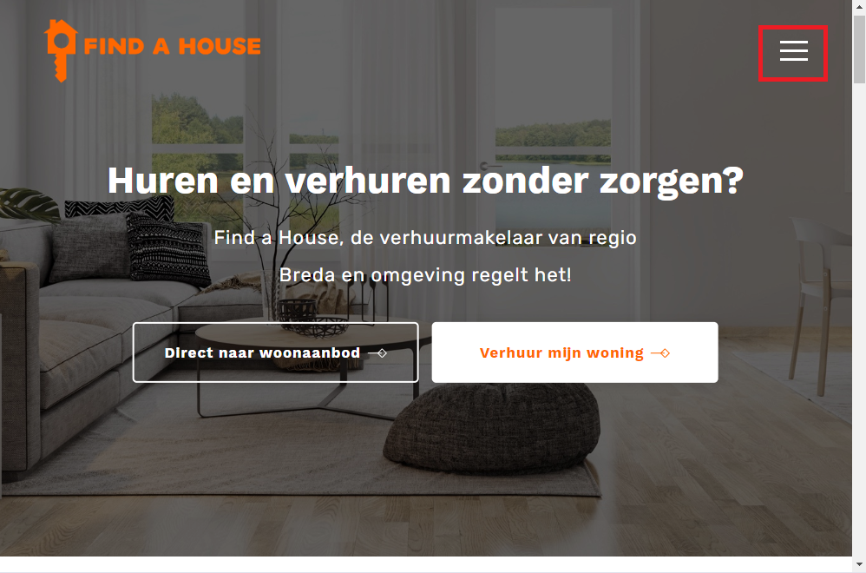

2. Click on the “Inloggen” button to open the Login form.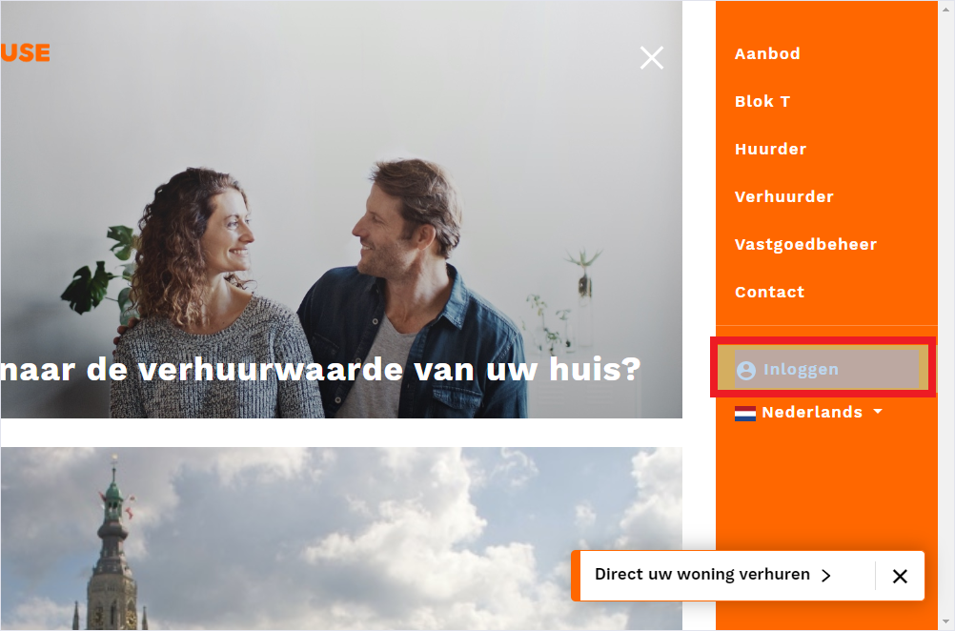

3. Click on the button "Registreer."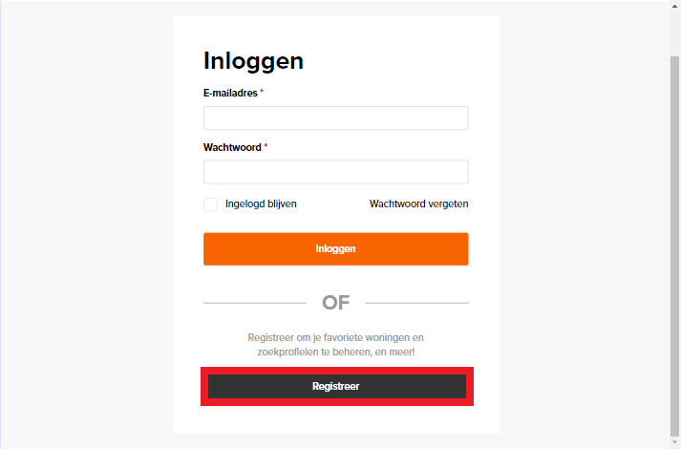

7. Fill the form correctly, then clink on the button "Registreren".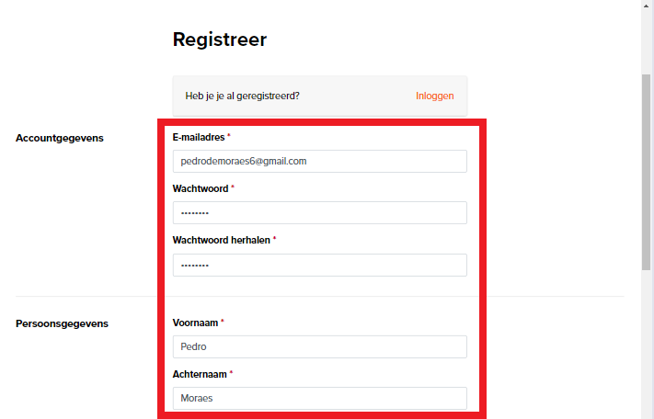

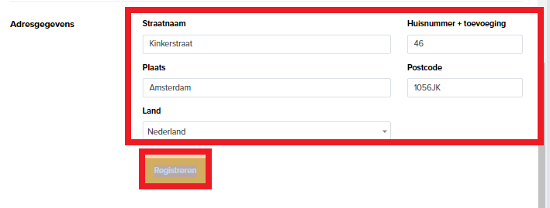

8. The account is made.